<https://www.youtube.com/watch?v=WMy3OzvBWc0>

UEFI puts all the boot code into one partition.

BIOS first stage GRUB looks in the partition table for location of the 2nd stage GRUB where it has the instructions to find an load the Kernel name and its location.

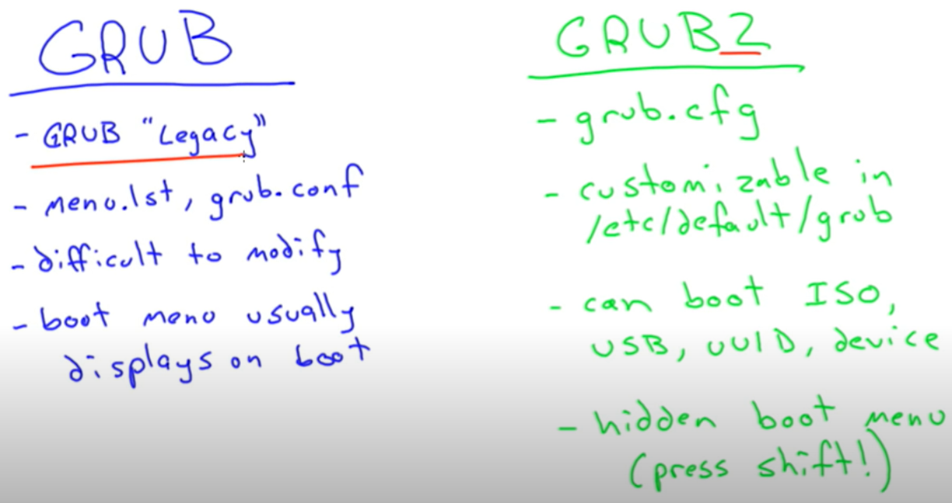

Slackware still uses GRUB legacy

Grub2 allows to do more configuration.

After making changes to /etc/default/grub, run update-grub. This will update the /boot/grub2/grub.cfg

In Grub2, to find the boot menu we need to hold the ‘Shift key’ to view the boot menu.

PXE = preboot execution environment.

TFTP is a server where we can store files remotely.

iPXE uses HTTP to download the boot file.

Windows also can boot from USB or CD

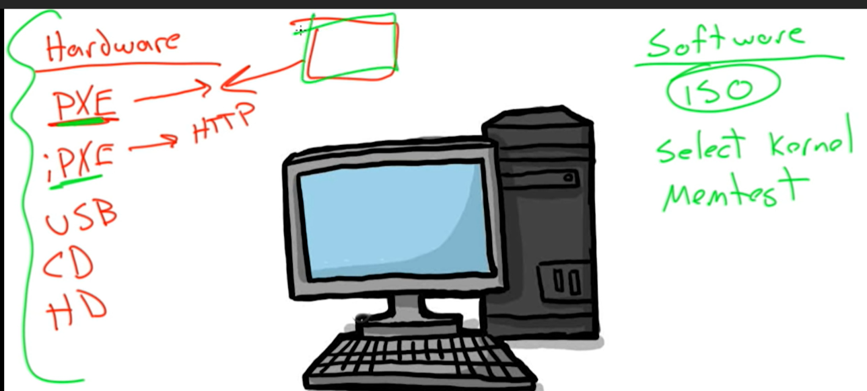

Initrd is initRAM disk, which provides information about the modules to the vmliux. It’s used only in the boot stage.

InitramFS lives in the vmlinux. Vmlinux is a very small kernel. Vmlinuz is compressed.

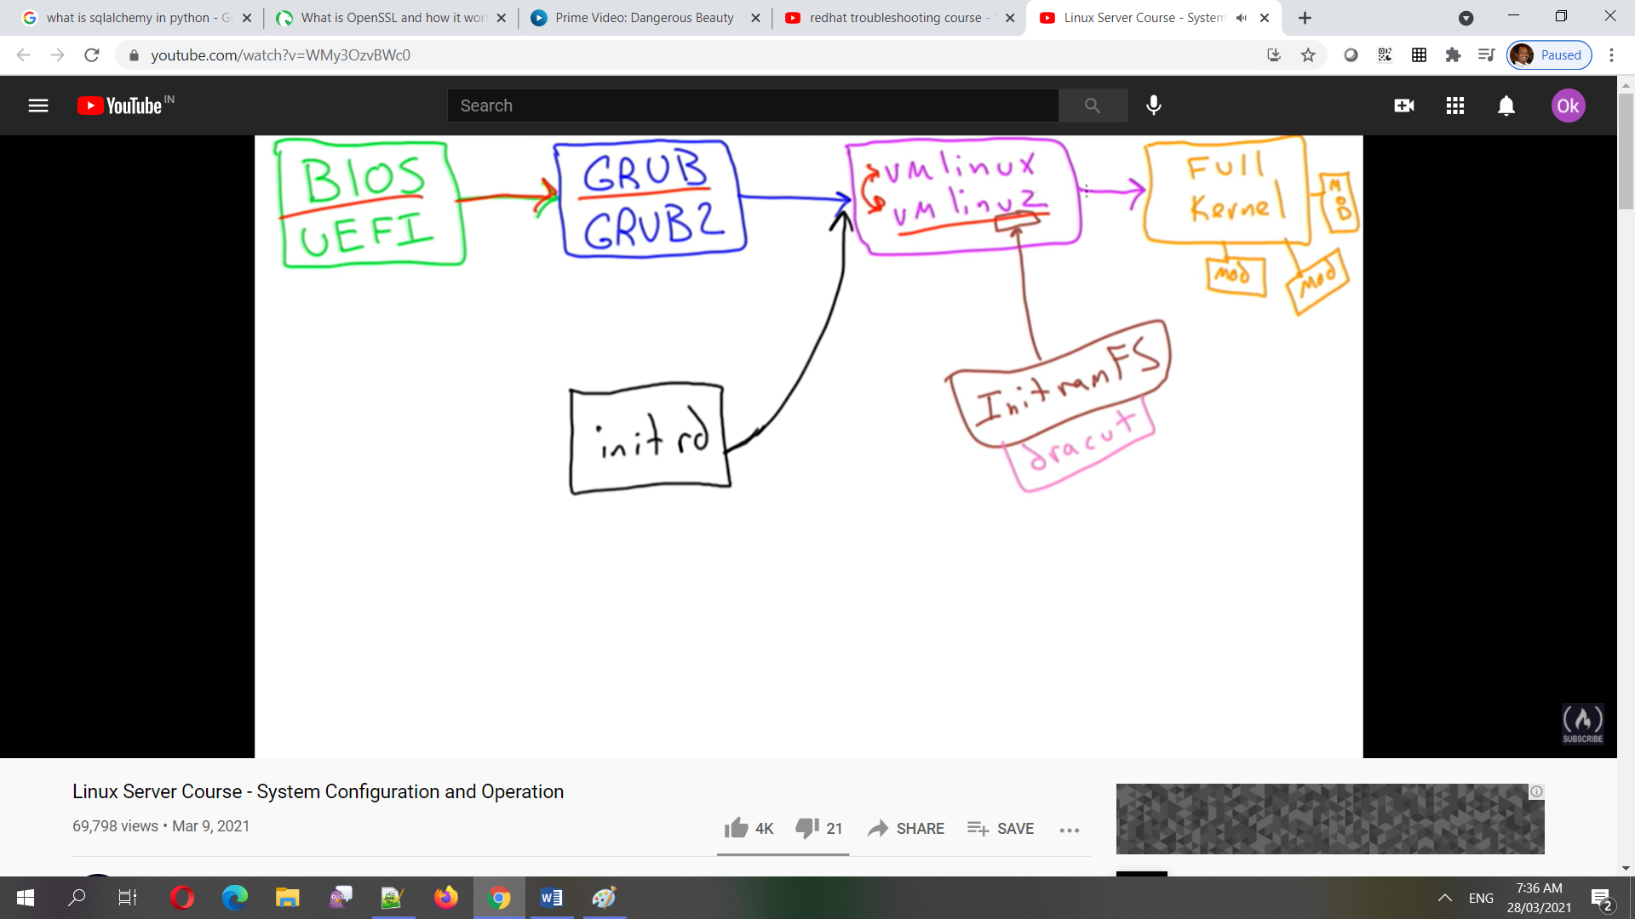

Inside /boot, the system.map tells where the file system and modules live, config gives the configuration files when the kernel compiles

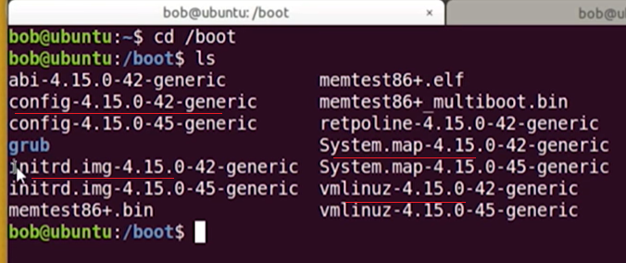

When the system fails to boot after a kernel update, reboot the system, press shift key to show the different kernels, then choose the older version which is used before the update. Then remove/reinstall the newest kernel. In another way, boot from cd or usb and access the system disks to save the date to another computer.

Manually we can enter the modules to be loaded at boot time into /etc/modules

When a module should be prohibited from loading, we can put it into /etc/modprobe.d/blacklist.conf

Linux kernel is modular – means only the required modules has to be loaded into memory.

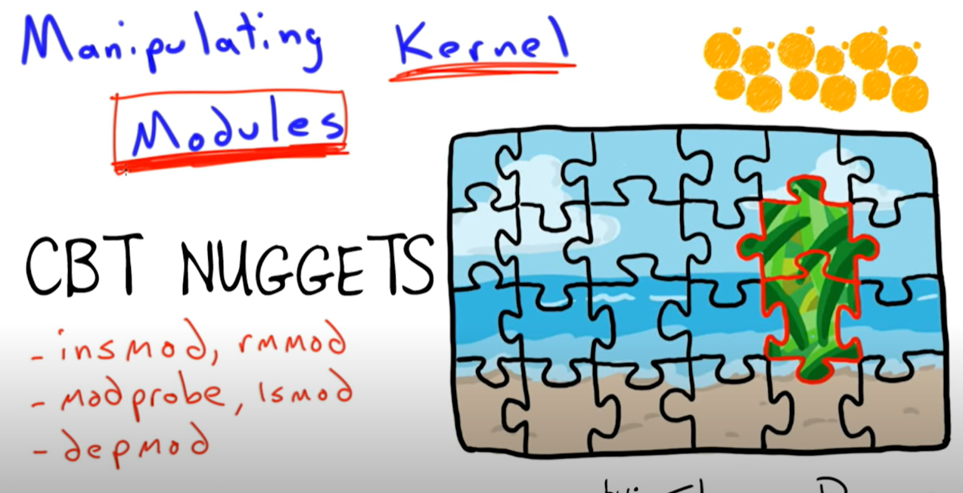

Modprobe uses insprobe internally to insert the modules.

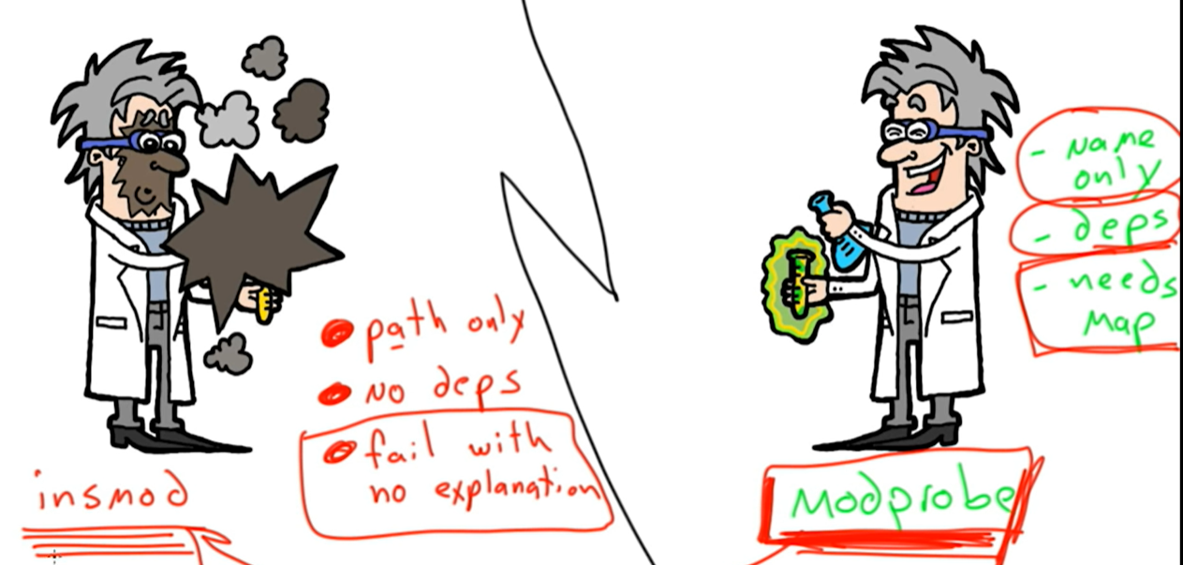

Lsmod = gives a list of installed modules.

When removing a modules, first remove its dependency, then the module itself. Use ‘rmmod’

After installing a new hardware, run ‘depmod’ to update the system.map file, so that the modprobe can find the module for that hardware.

Ping, ip add, ip route (for routing information). Think like a packet for things that are required to find the addresses.

Dig, host, nslookup:

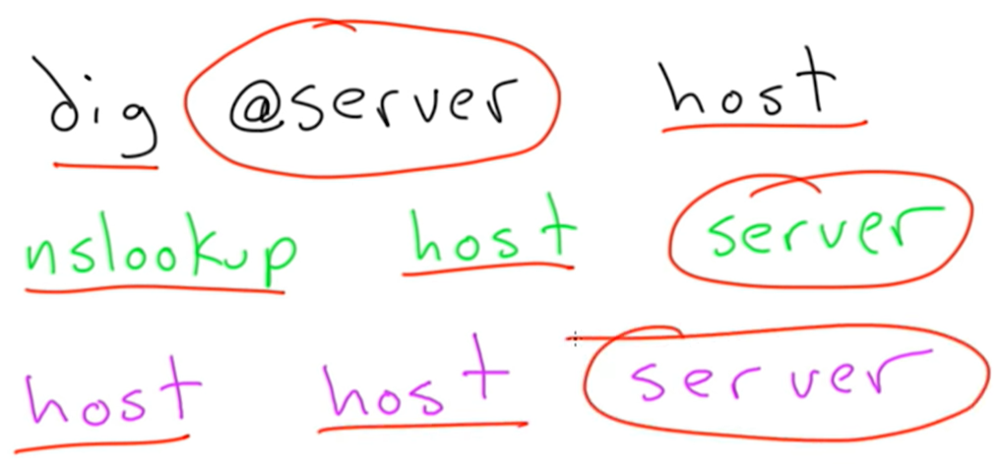

After editing the etc/hosts, run dnsmasq restart

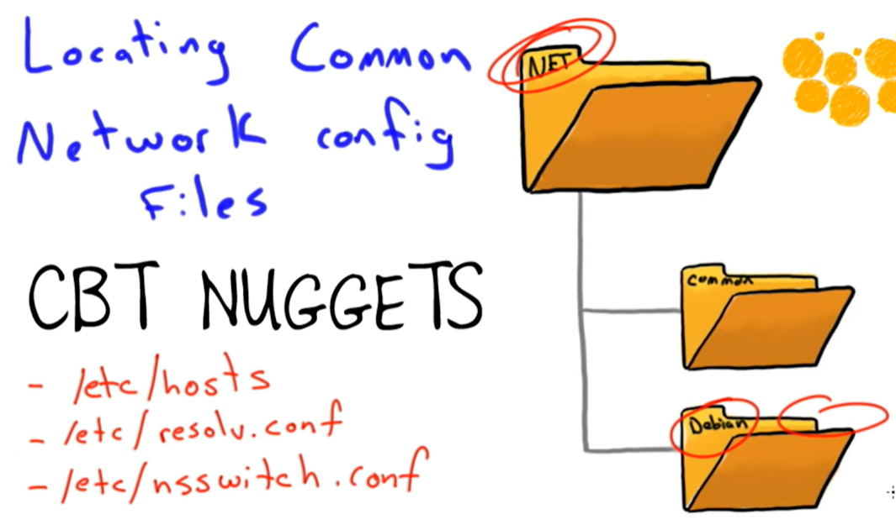

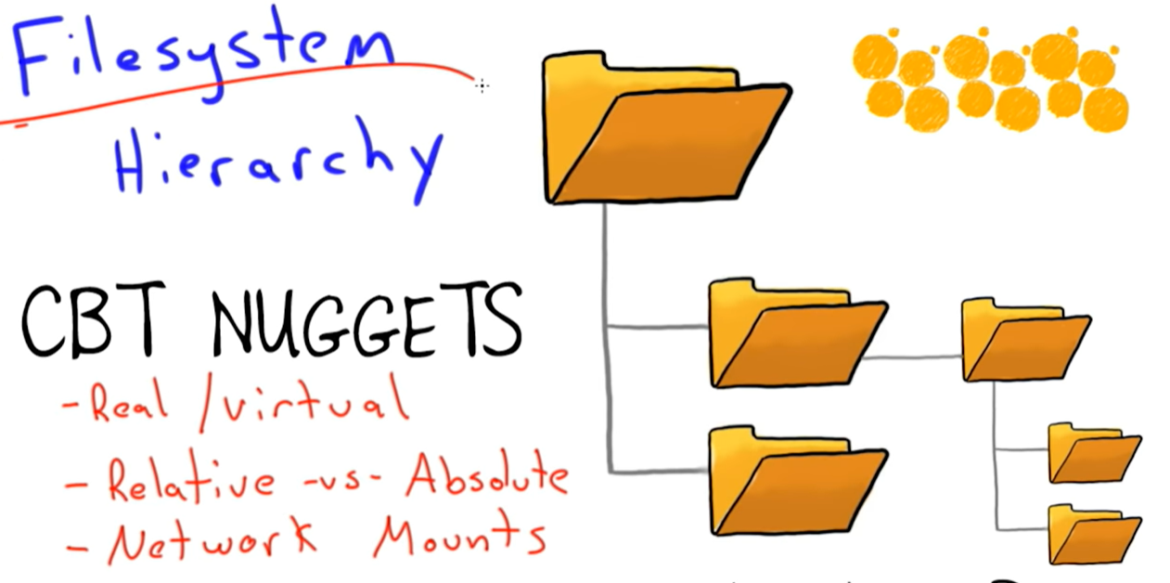

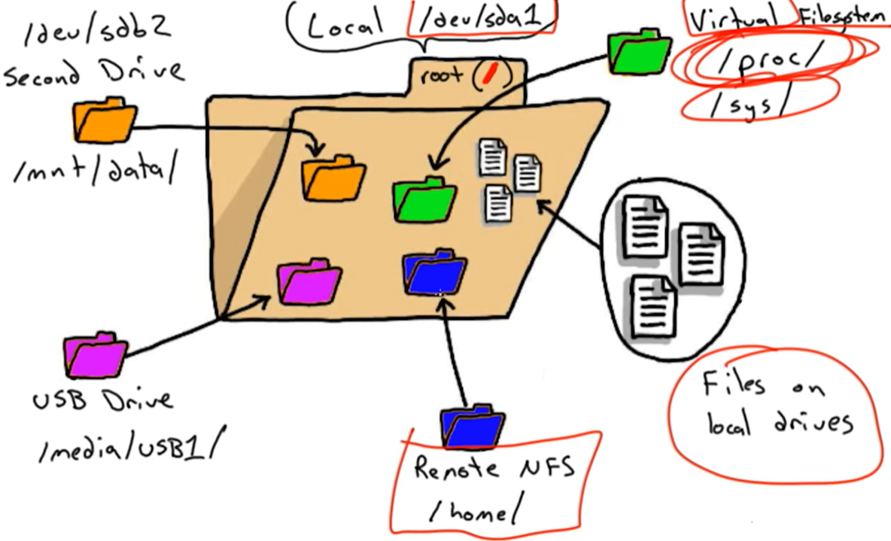

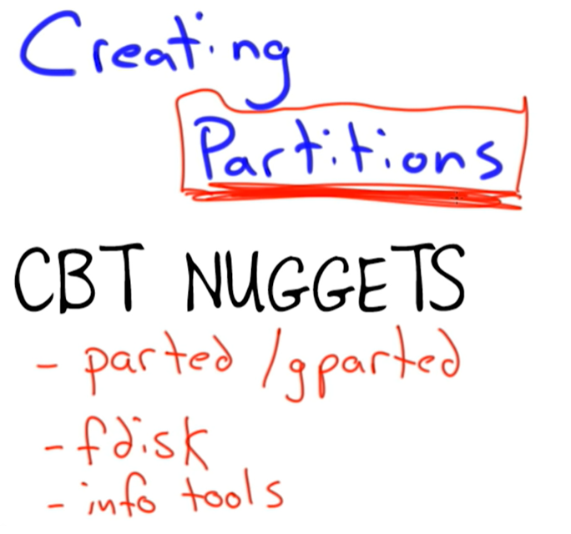

Lsblk, cat /proc/partitions, ls /dev | grep sd

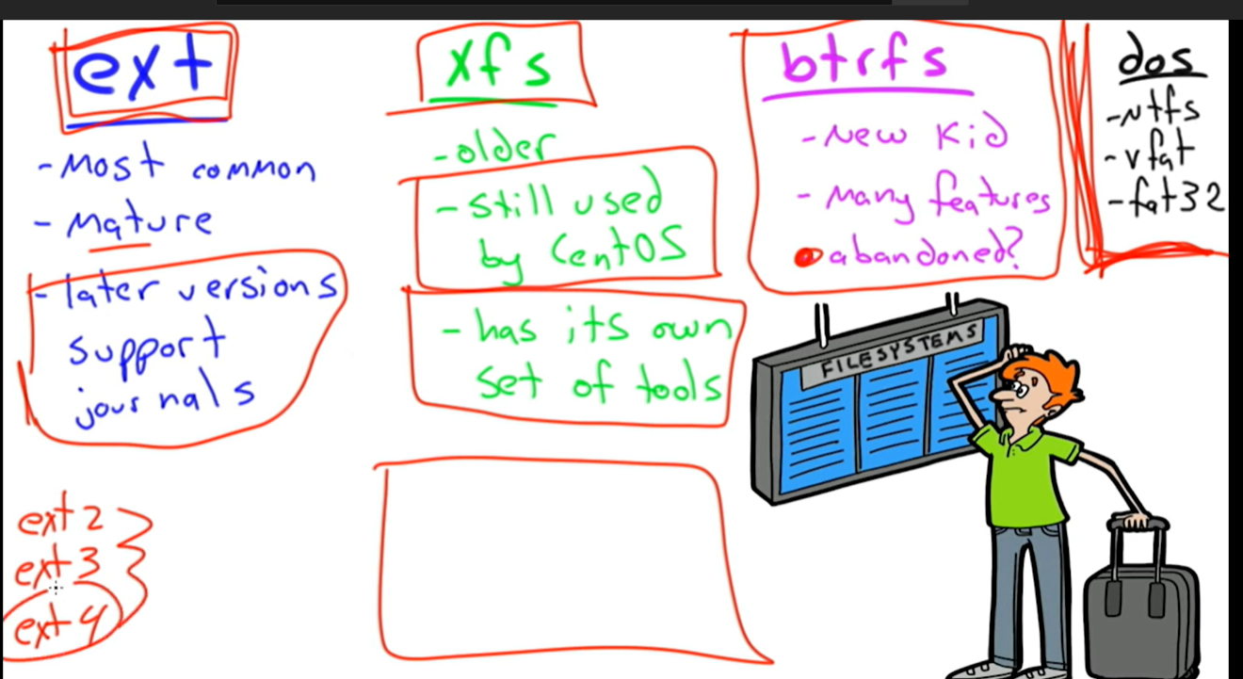

Filesystems are mounted onto an empty folder in the filesystem tree.

Blkid

/etc/fstab // mount –a

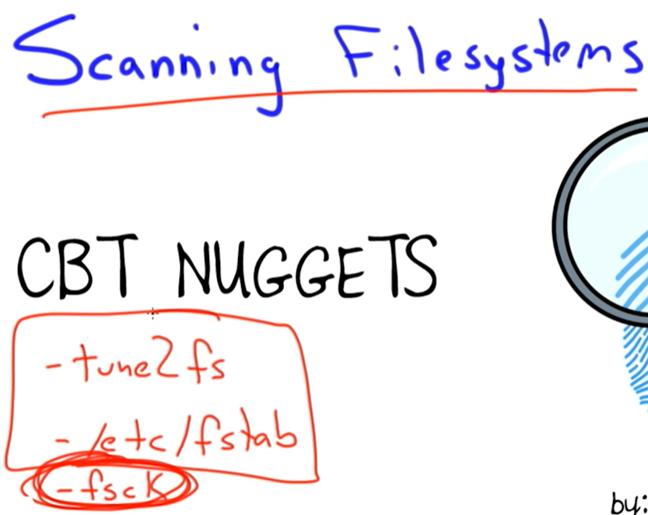

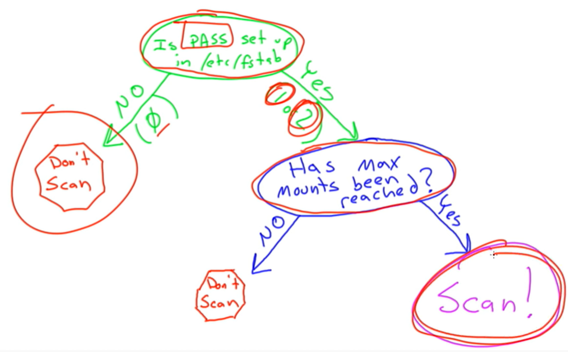

Tune2fs –l /dev/sdb1 = to see the mountcount and max mountcount.

Tune2fs –c 10 /dev/sdb1 = will set the fsck after restart of 10 filesystem mounts

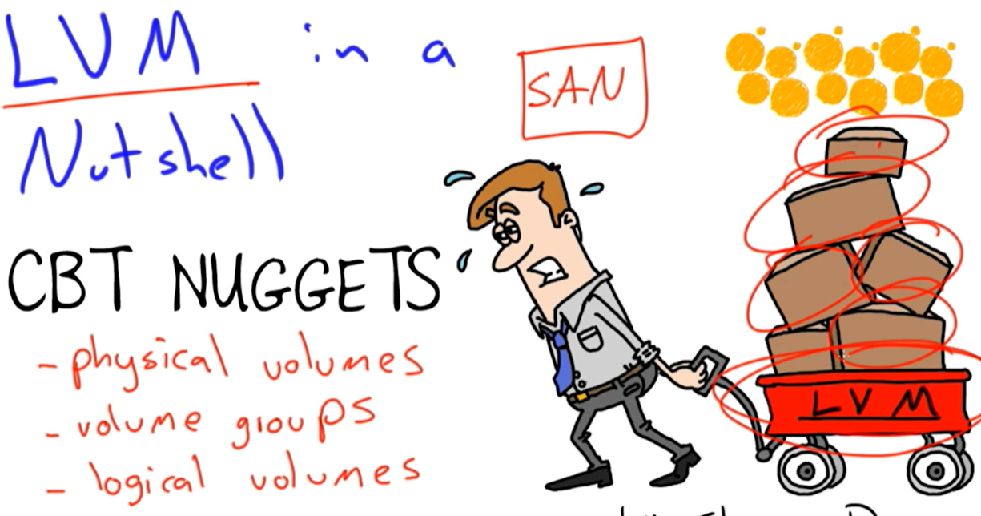

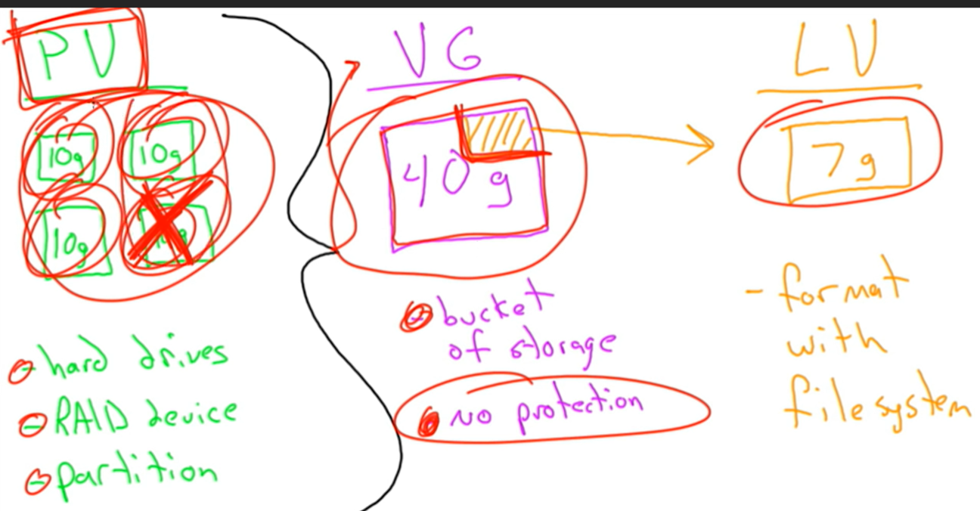

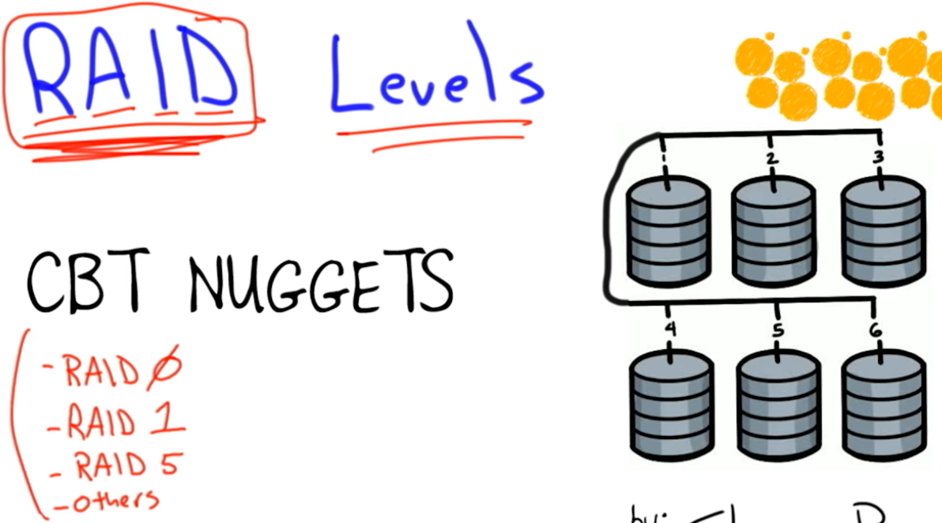

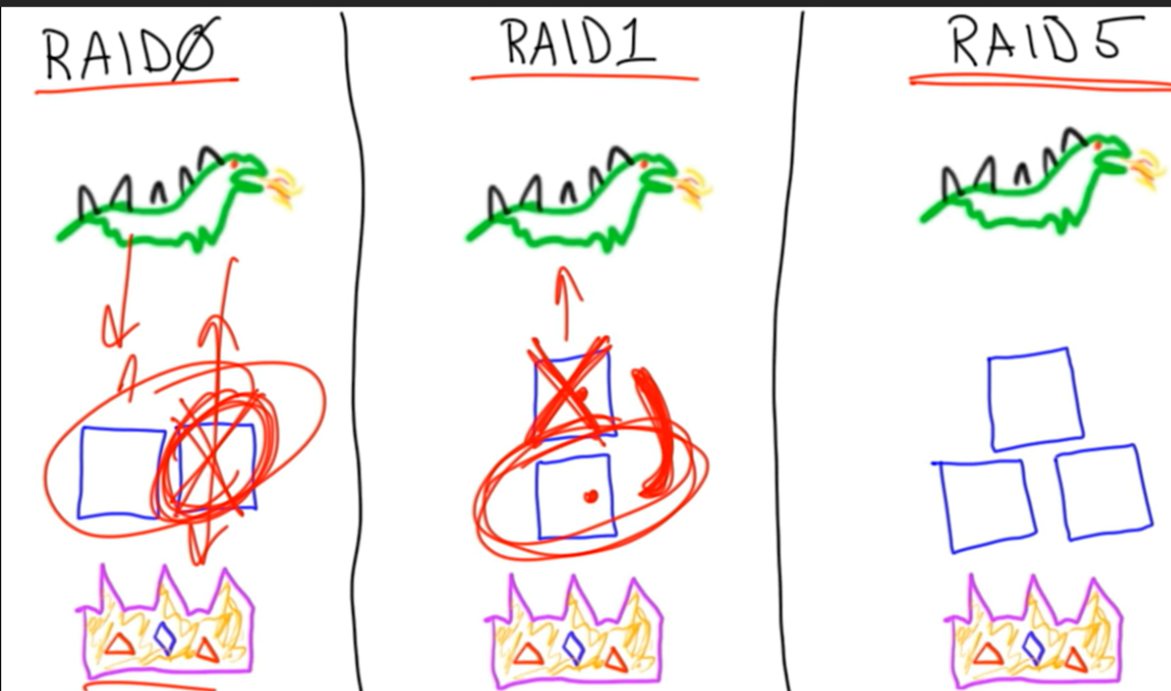

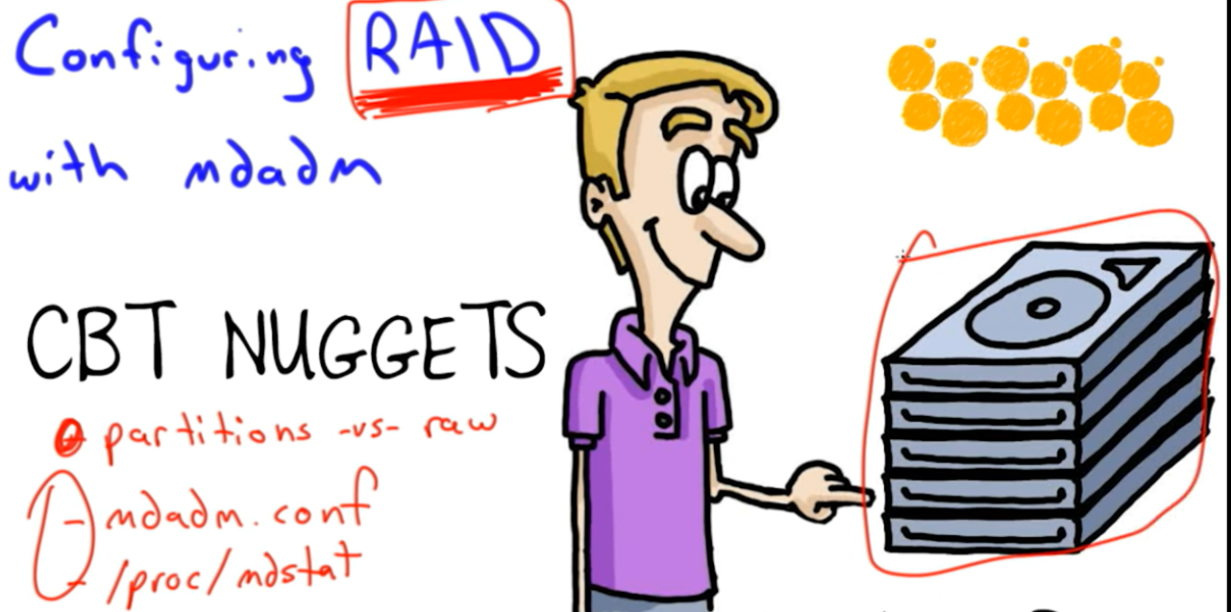

Create a RAID:

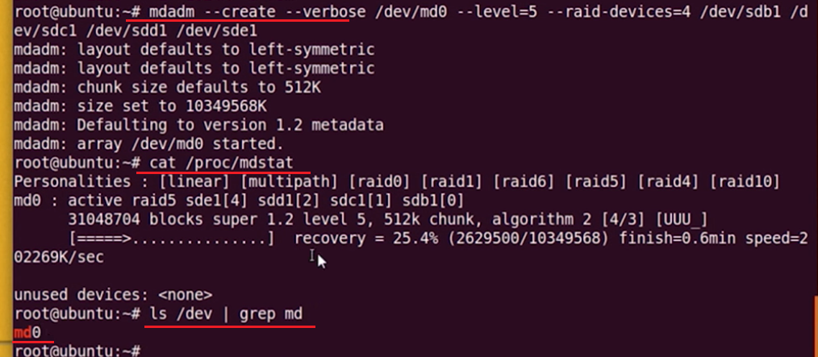

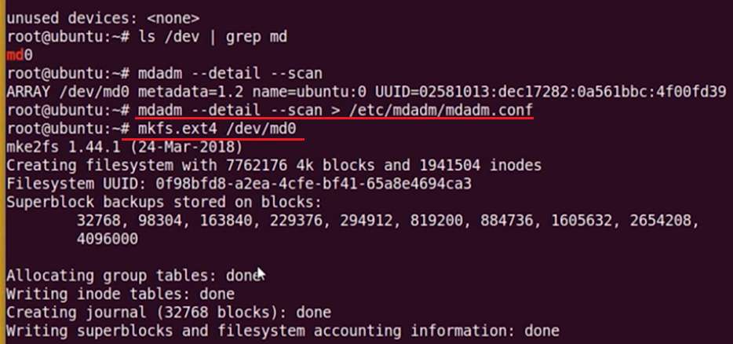

Tarball

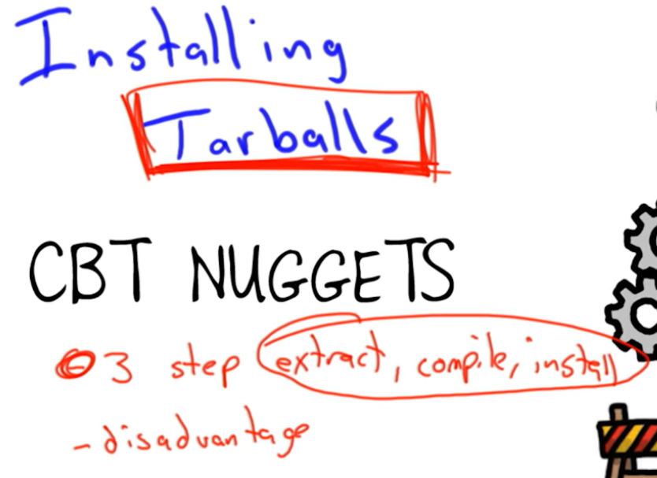

Run ‘make’ to compile then ‘make install’

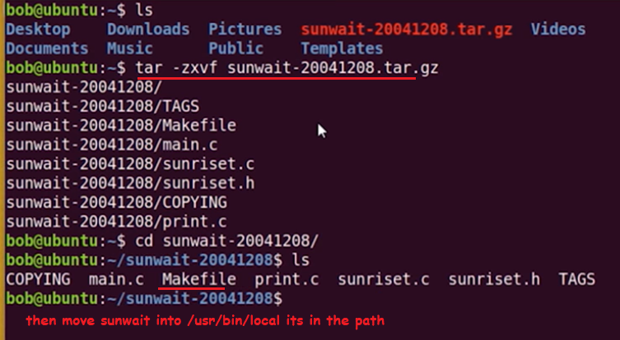

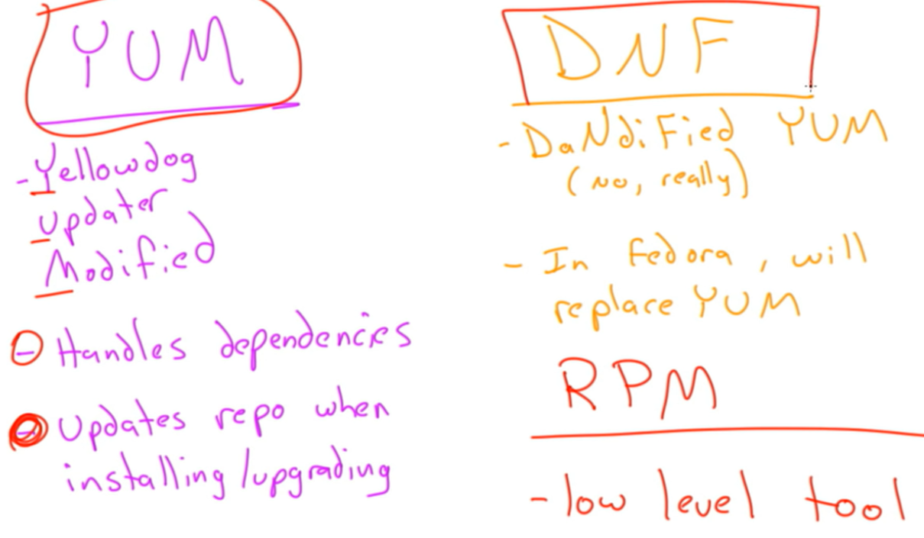

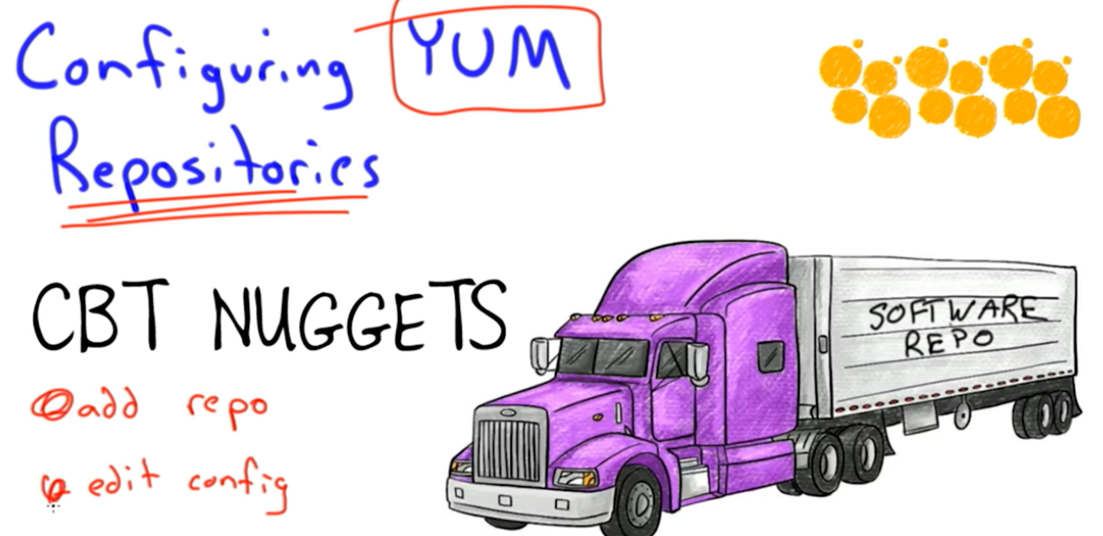

Useradd -h

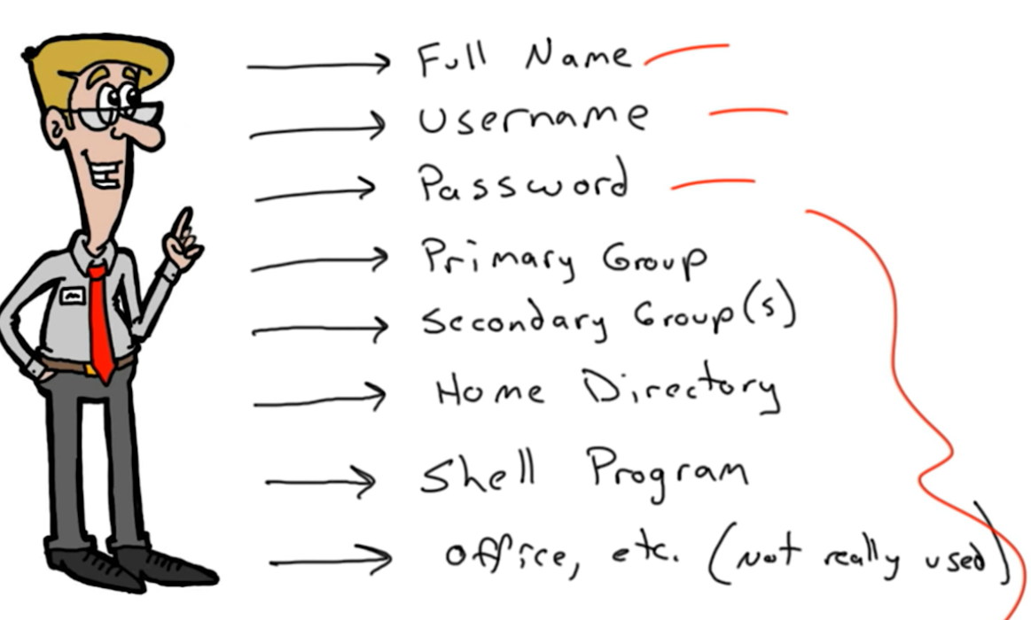

Adduser script

Pinky – to find users logged in

Last – gives a list of users recently logged in

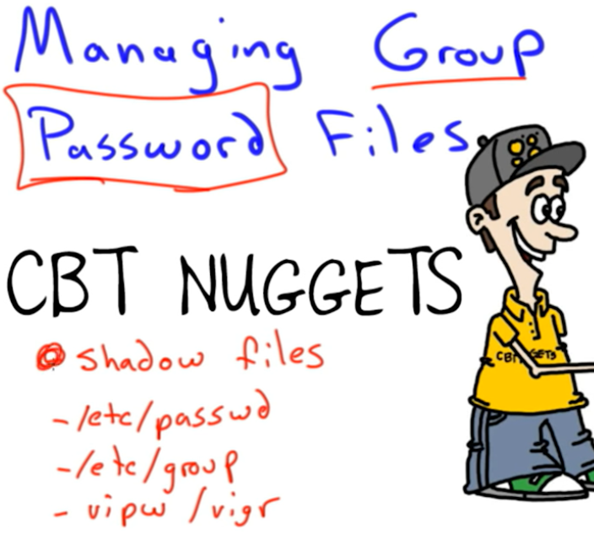

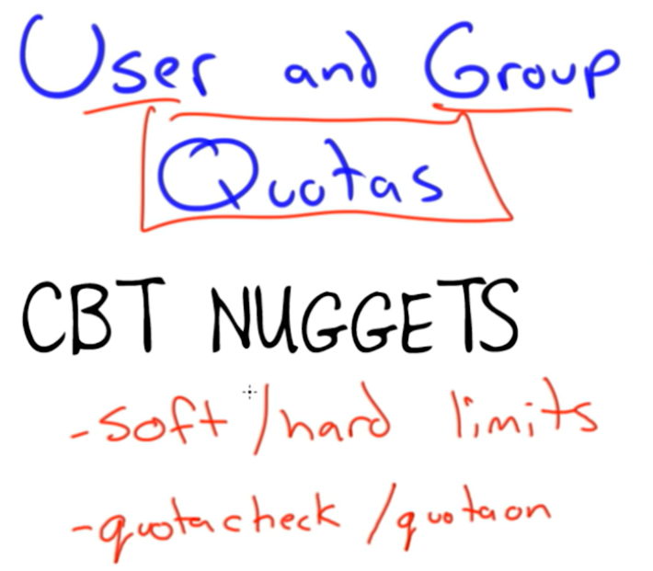

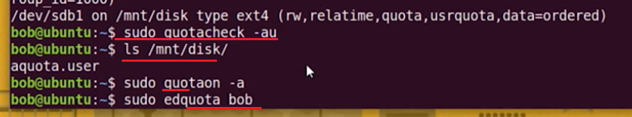

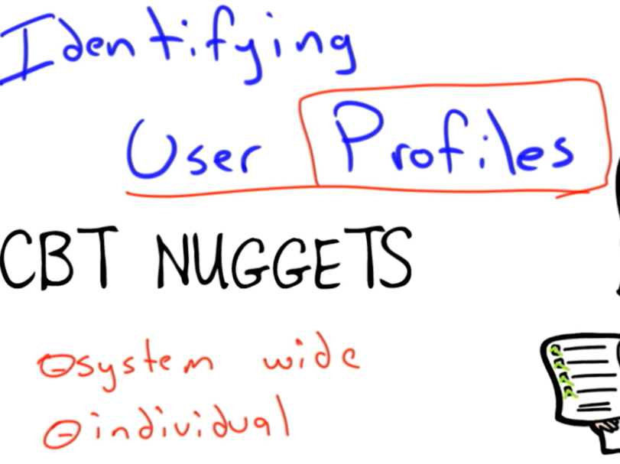

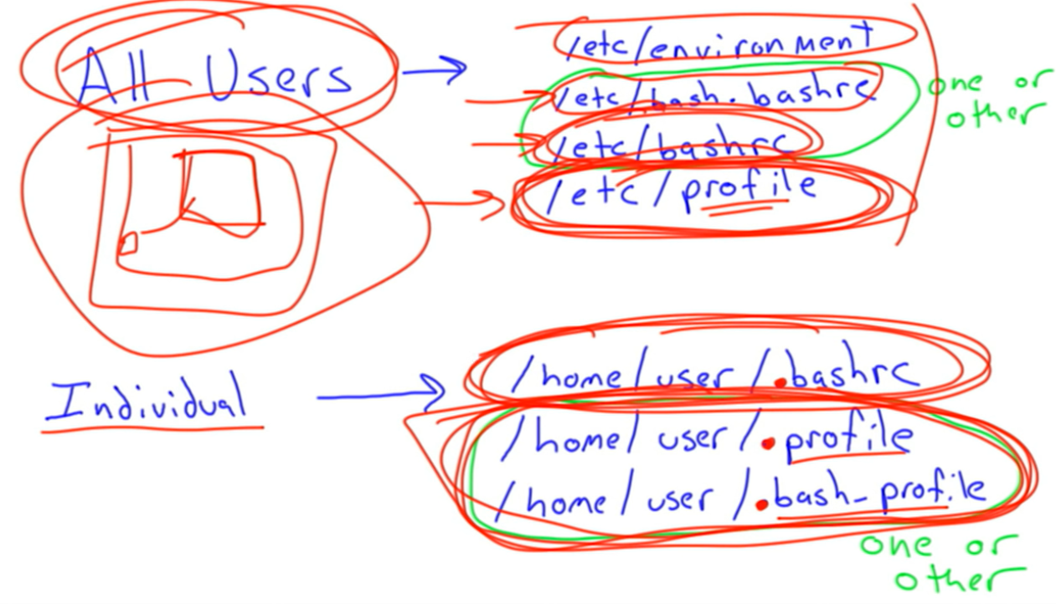

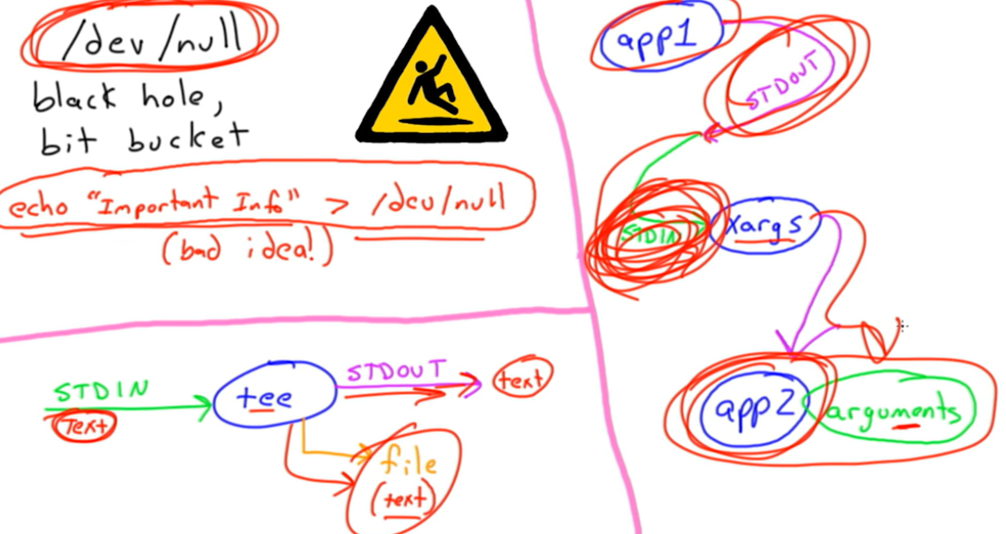

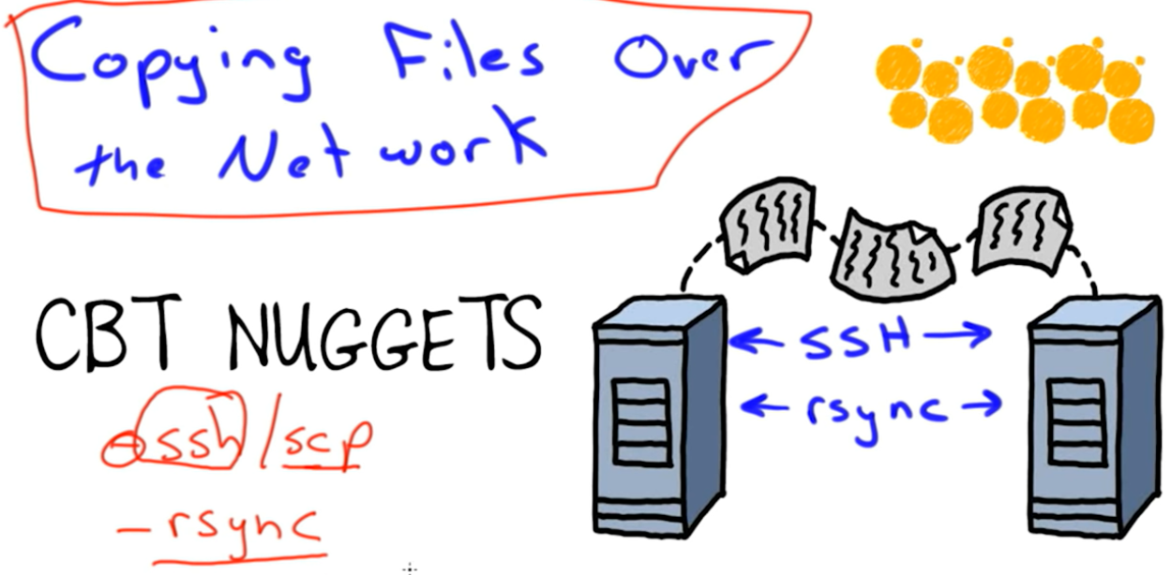

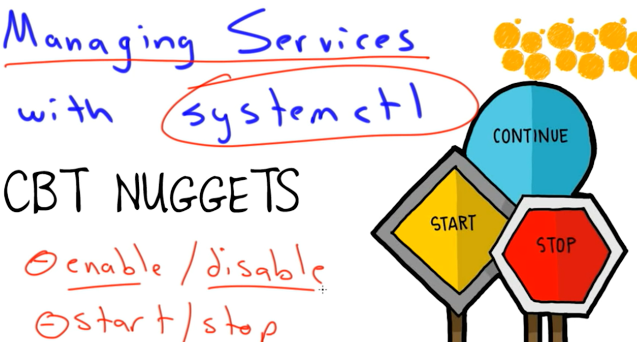

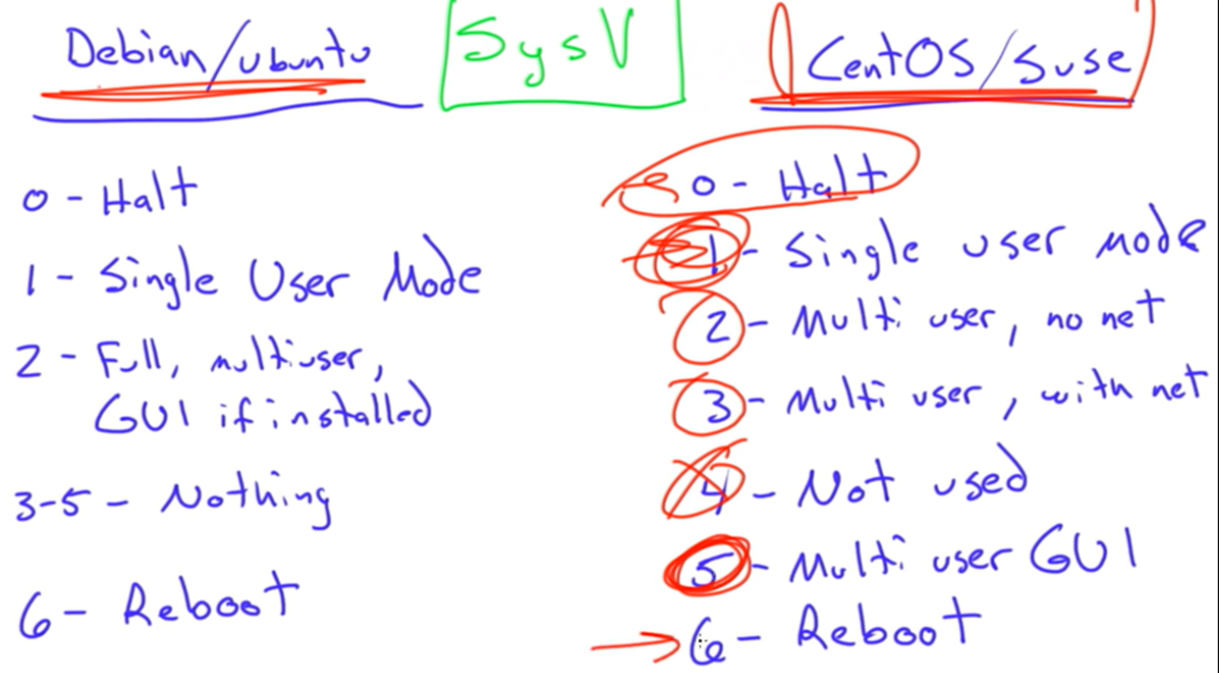

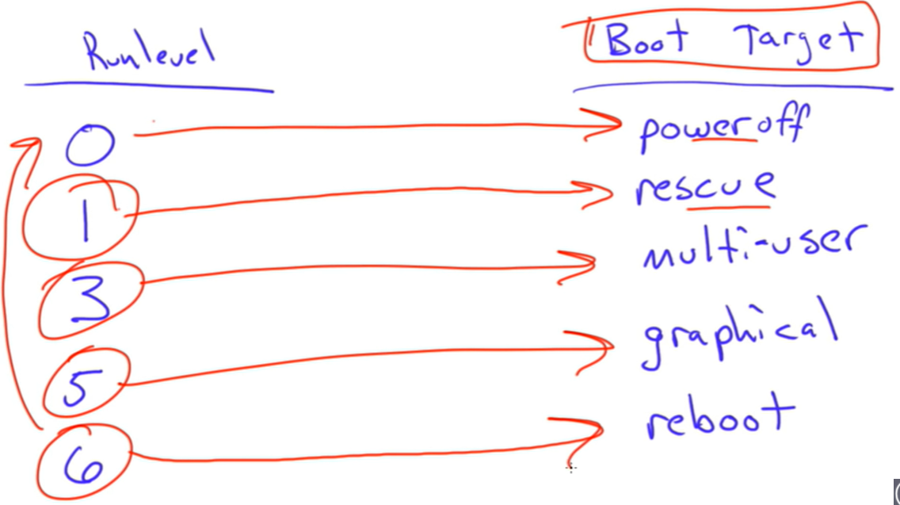

Services: ls /etc/init.d will show all the services

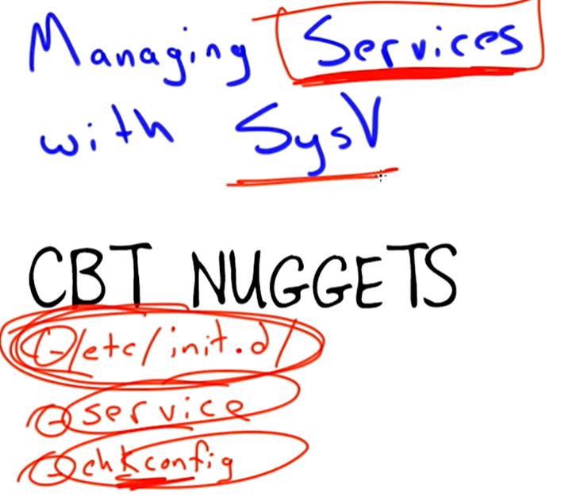

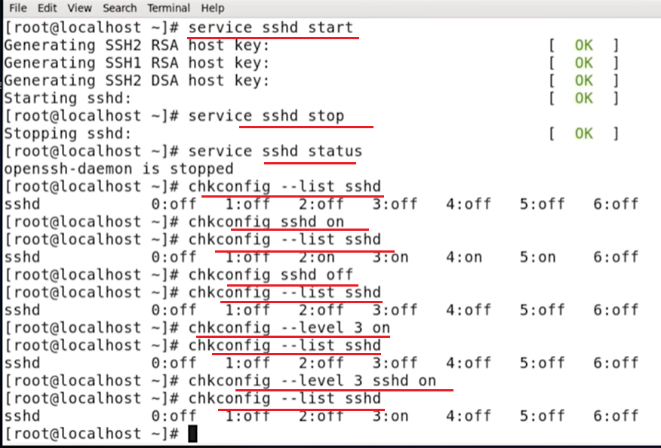

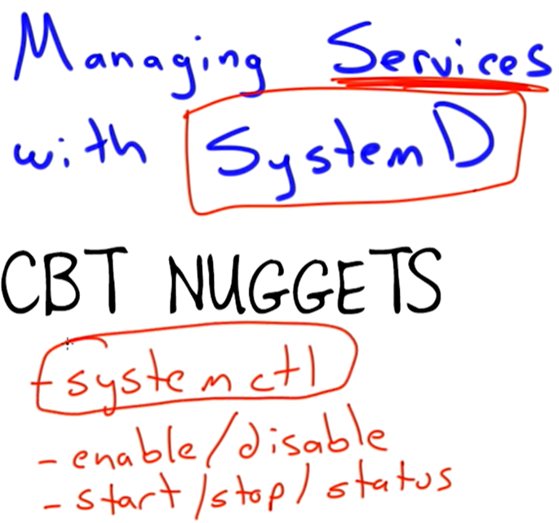

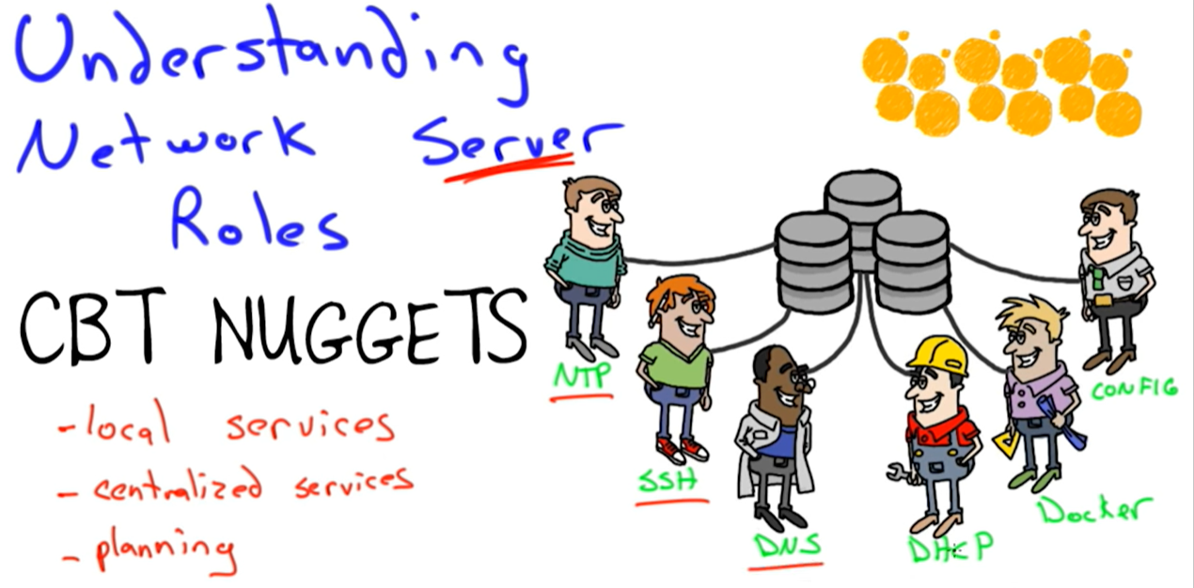

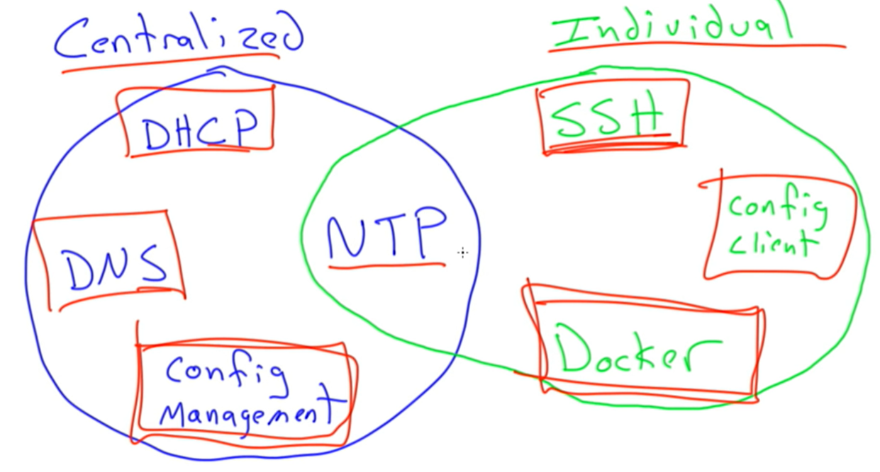

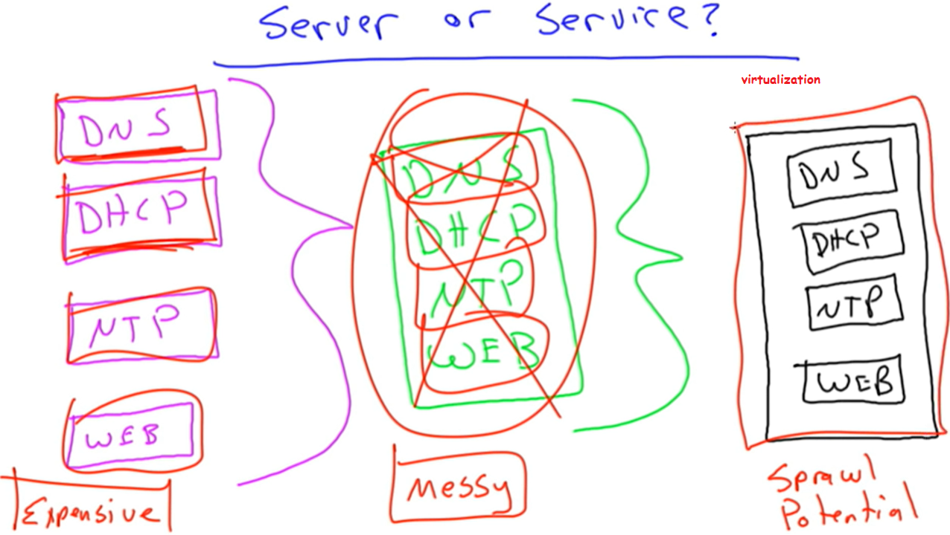

Ssl

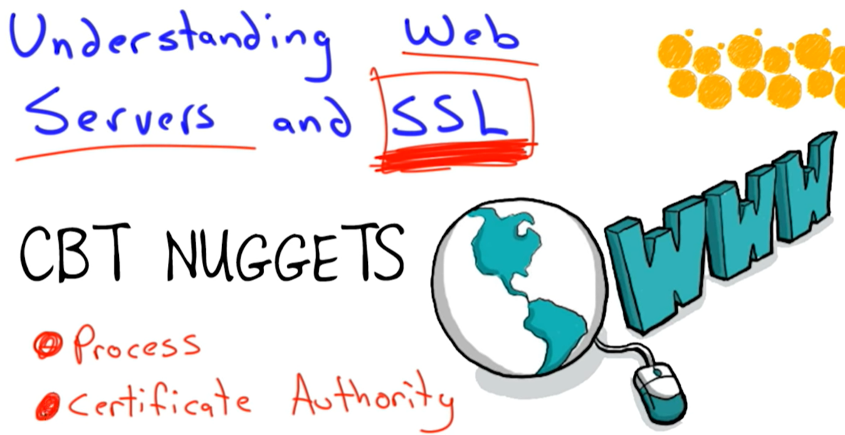

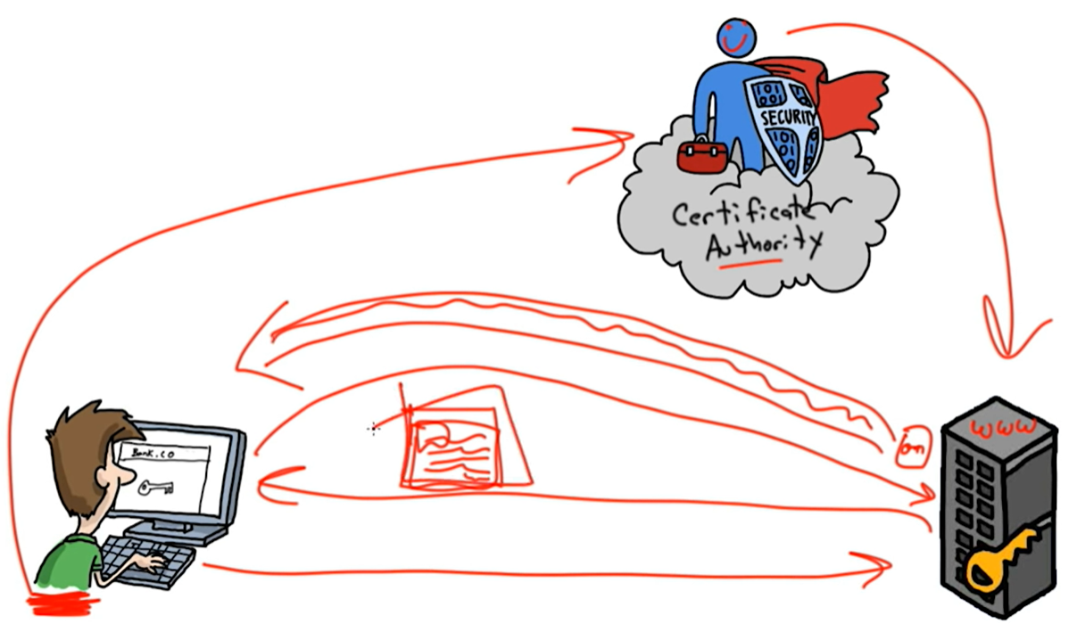

1. Client send request to server. 2) server replies with their certificate. 3) client forwards that certificate to the certificate authority. 4) CA checks the certificate with the server and if correct, signs it. 5) CA sends the signed in certificate to the client. 6) client sends the encryption key to the server. 7) server uses the encryption key to encrypt all communications with the client henceforth.

In a local network, its okay to accept the self-signed certificate, but not in an internet.

Linux printing: CUPS (common unix printing system)

Web filter stops from going to pornographic sites.

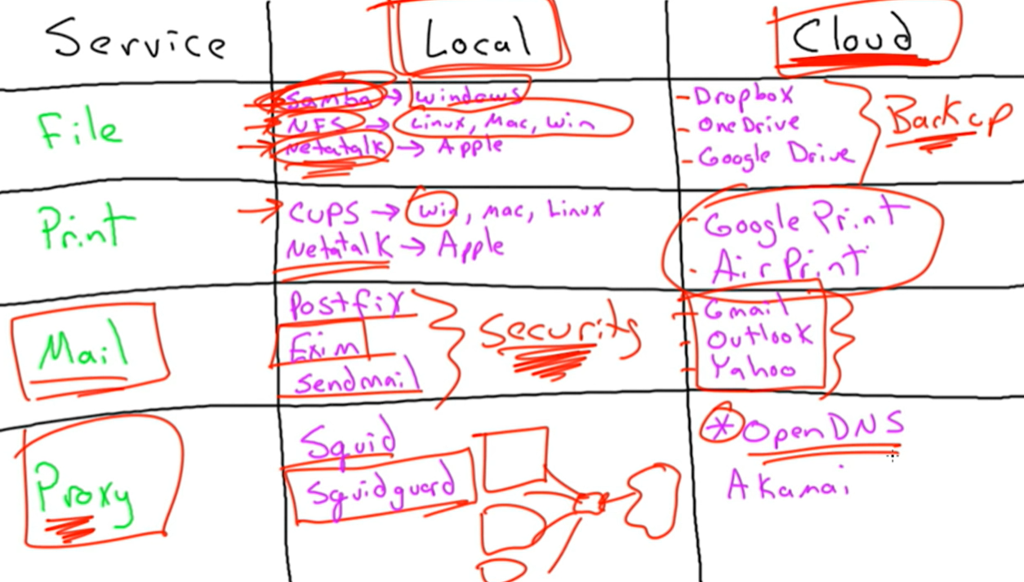

User authentication:

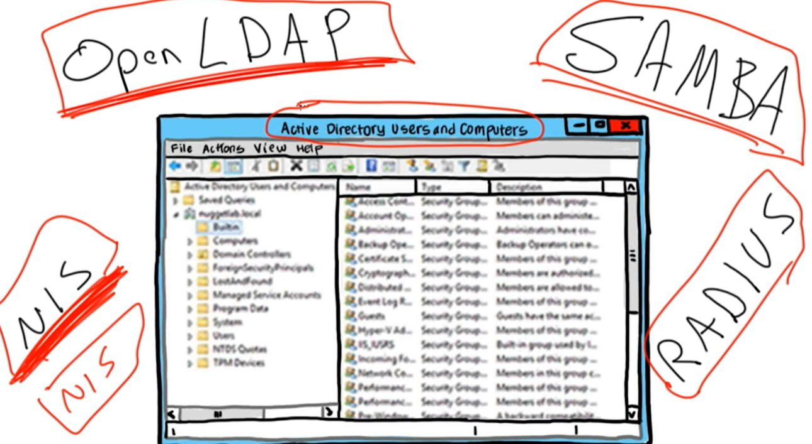

In VPN, a tunnel setup first, which protects the communications through the tunnel from intruders.

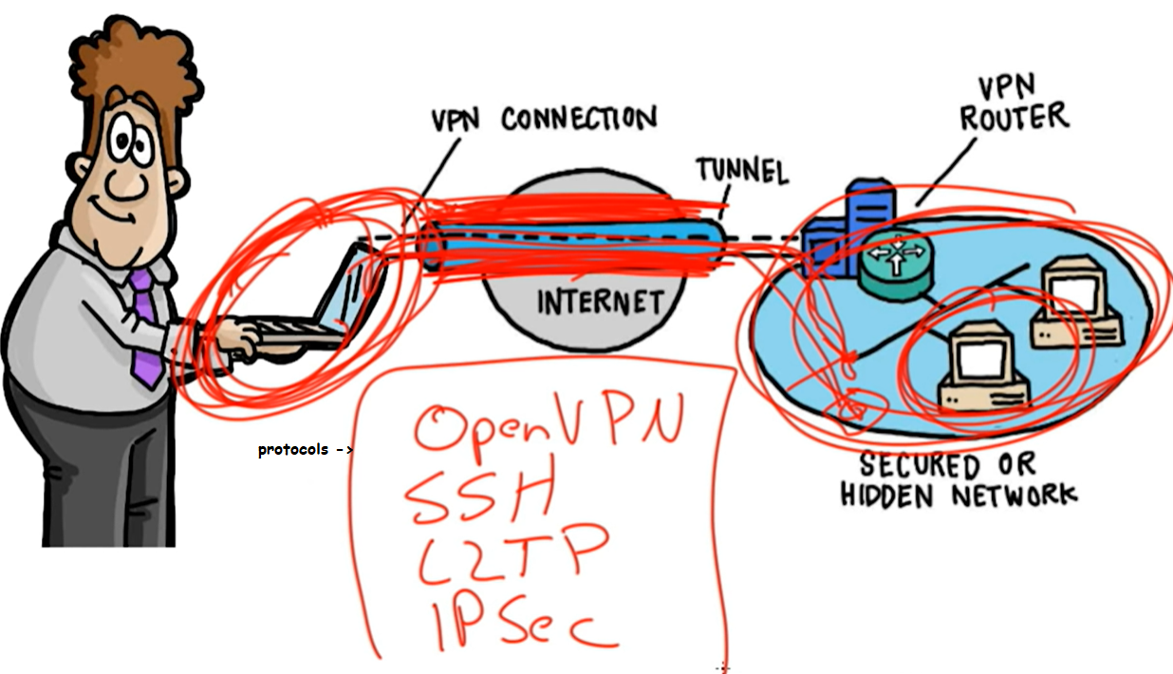

Containters:

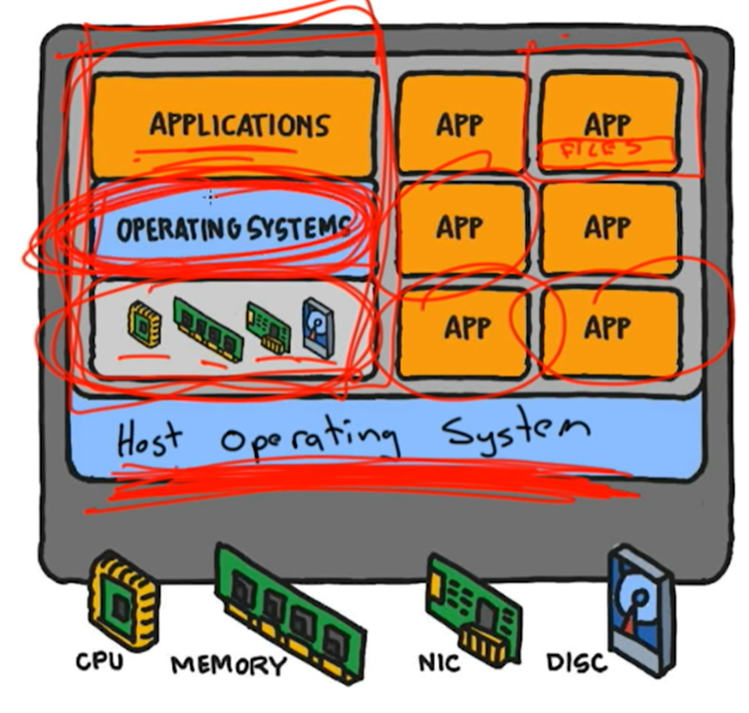

Containers does not have their own OS. It uses the host OS.

Clustering is combining multiple computers to achieve a single task.

Load balancing is the distribution of workload to different machines. The domain name can be the same, but the ip address will be different.

Cron:

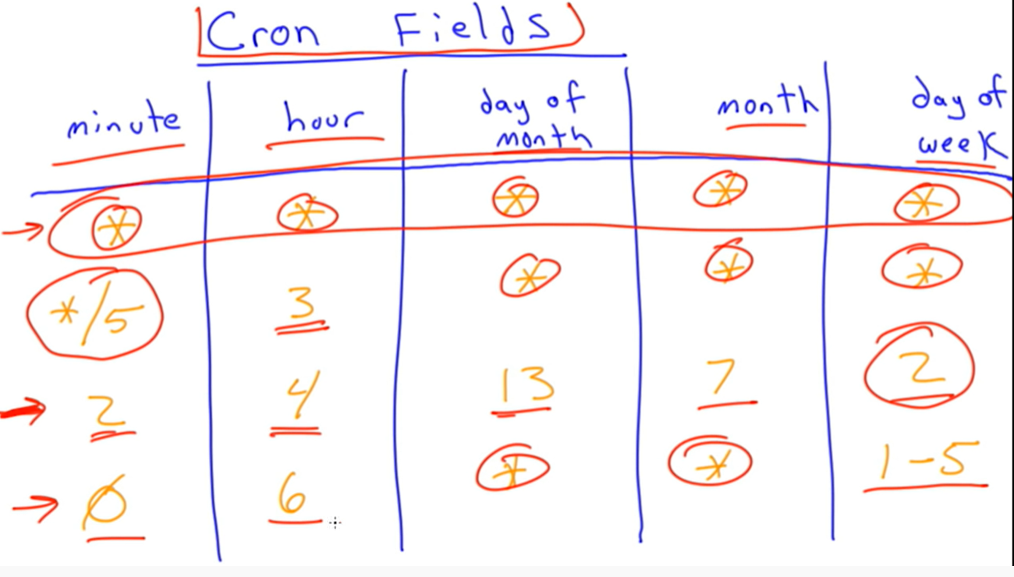

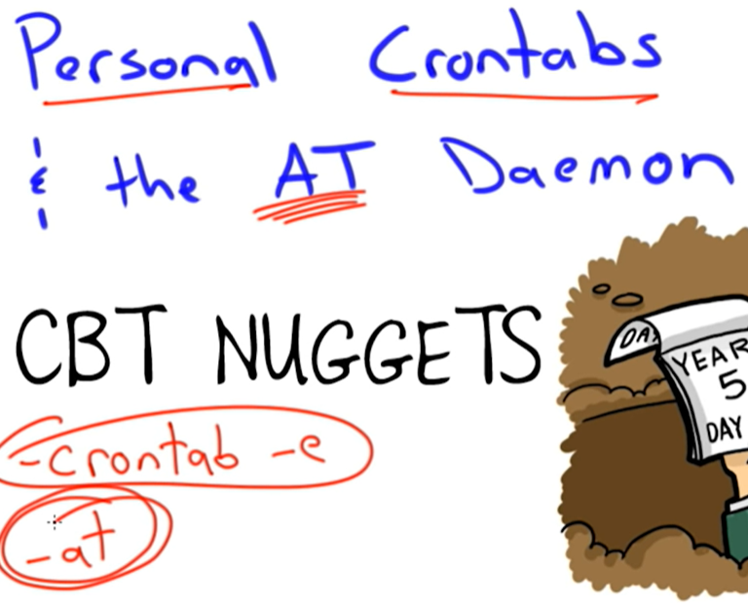

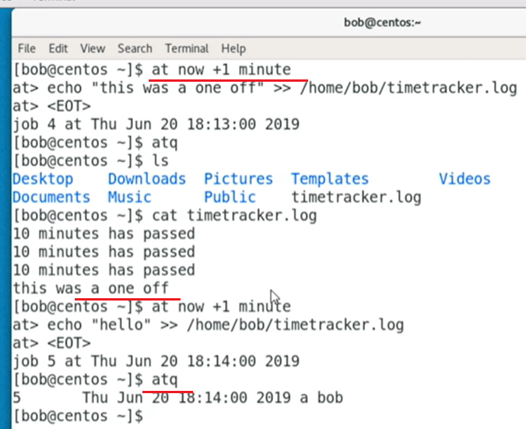

Crontabs for systemwide jobs, crontab –e is for personal jobs and ‘at’ is for one time job.

Background and foreground jobs:

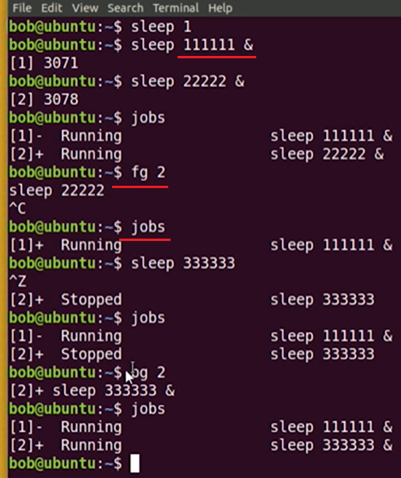

Nohup jobs doesn’t stop when the user logs out. It keeps running.

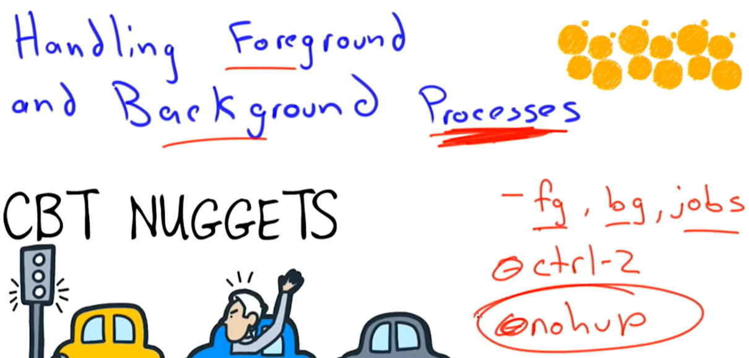

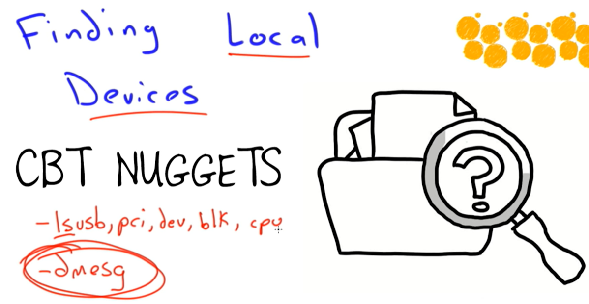

Proc, sys, dev are virtual file systems. Proc has process information, sys has kernel info and dev has disk info

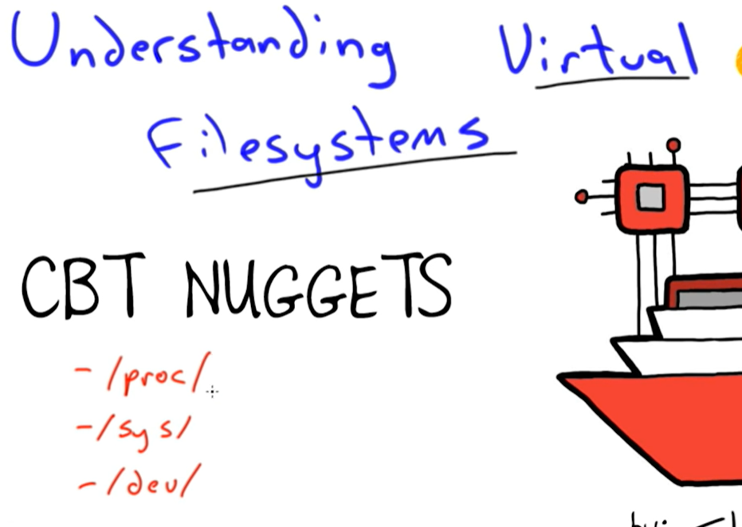

CUPS use webinterface

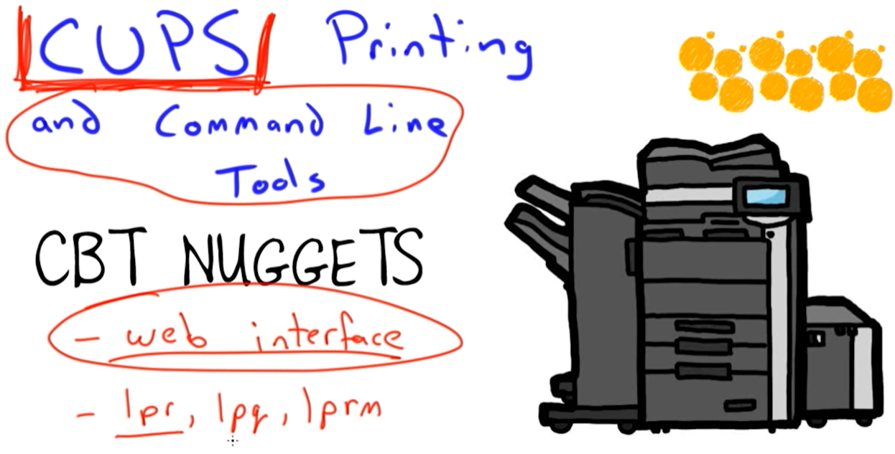

UDEV is device manager

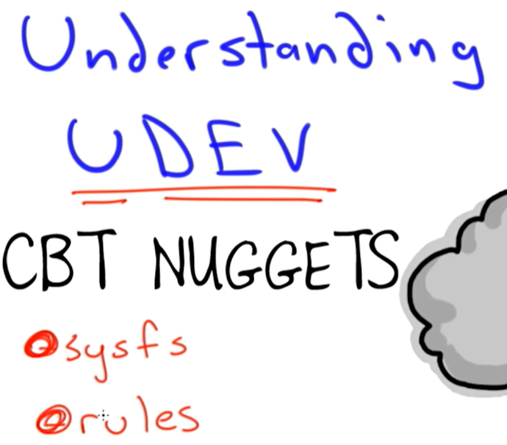

Sysfs is a file system that has information about the hardware.

Udevadm info

/etc/udev/rules.d

Udevadm trigger

<https://www.youtube.com/watch?v=VF7moZfa4Fo>

chroot:

chroot command in Linux with examples

* **Last Updated :** 15 May, 2019

chroot command in Linux/Unix system is used to change the root directory. Every process/command in Linux/Unix like systems has a current working directory called **root directory**. It changes the root directory for currently running processes as well as its child processes.  
A process/command that runs in such a modified environment cannot access files outside the root directory. This modified environment is known as “[chroot jail](https://www.geeksforgeeks.org/linux-virtualization-using-chroot-jail/)” or **“jailed directory”**. Some root user and privileged process are allowed to use chroot command.

[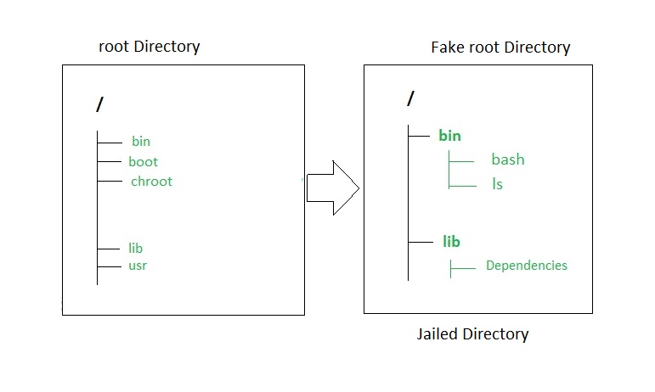](https://media.geeksforgeeks.org/wp-content/uploads/chroot-command.jpg)

“chroot” command can be very useful:

* To create a test environment.
* To recover the system or password.
* To reinstall the bootloader.

*starend